**B**

**Outline for Cable TV Channel ABCD International**

**Ruotong Xu**

**Bachelor of**

**Software engineering** **(Honours)**

**ENGE 600 Engineering Management I**

**AUT University**

**Auckland**

**08/2018**

Abstract

This outline will give some suggestion for ABCD International film company some advises by using engineering and management. In engineering function part, the suggestion will start from how to use less budget and time to achieve better effect in the film. The engineering function part also includes the details of the film costs so that simulate accurate situation during filming. Due to the reason that the engineering function is not only limit in the time and budget calculation, after that this outline will give a suggestion for the best budget and money scheme for this project.

In order to make sure the job is always doing by the correct person, we need to use the management function, in this part this outline will trying to make the job separate in to serval parts to each role in studio which is most suitable for this part. There is no doubt that employee type will be introduced in this part, and also there is a recommended amount of each type of employee after the introduction.

Contents

1 Engineering function 1

1.1 1

2 Management function 2

3 Discussion 3

4 Conclusion 4

# Engineering function

For the primary goal in engineering function is to save time and money during filming. The main parts of the ways to implement this goal is to control travel route as reasonable as possible, organise the recording materials and people of ability that will be necessary in filming, depend contents of documentaries which need to be filmed.

# 1.1 Travelling

Assuming that ABCD International company is a New Zealand company and all staff stay in New Zealand. The best route in traveling is to fly around the world and duplicate route will not be allowed during travelling due to the reason that duplicate route is time consuming and waste more money in travel to each country (except serval airplane company has preferential policy for some duplicate route), the data for tour around world price will be shown later.

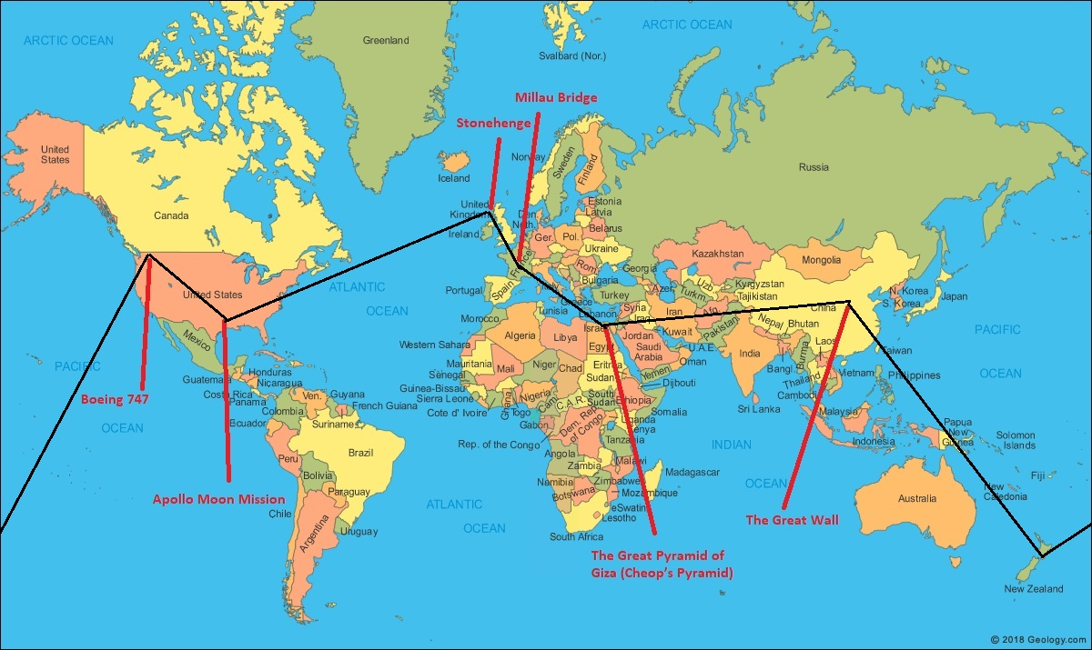1.1(1)

The route is as the black line picture1.1(1) shows.

After the Boeing 747 documentary finished,

# Management function

# Discussion

In this discussion, the start and finish for this story will be discussed. In generally the story will follow the time line in real life. It is easy for people to understand how the engineering management works for every project which has the best management technique in each different period and how engineering management developed in this 5000 years (From Stonehenge was built to Apollo Moon Mission finished).

* 3.1 Start of this story

The story can either choose England or U.S as the start. First of all, the reason that we choose England as the start for the documentary is the Stonehenge is in England which has longest history compared with the other projects that filmed in this series documentaries. The Stonehenge was built in 2500 BC. Due to technology that people had that time is very original and each stone in Stonehenge is extremely big compared with a size of a person, but people can still put them in the accurate position to measure the time of a day, it is quite difficult for people to believe people in that period have ability to build such things. People who are curious about how did the ancients build magnificent building must be interesting with this documentary.

Due to the most modern project is Boeing 747(Compared with Apollo Moon Mission started in 1961, Boeing 747 was put into operation in 1970), which is closed to normal life for most people. Additionally, airplane is one of the most convenience way to transport to each place, there are an average 9,728 planes in the sky every day, therefor people are familiar with the airplane. As a result, Boeing 747 should be a suitable point to start this series of documentaries.

# Conclusion

# Reference

https://geology.com/world/world-map.shtml

<https://www.planespotters.net/operators/Boeing/747>

https://www.travelandleisure.com/airlines-airports/number-of-planes-in-air

http://www.english-heritage.org.uk/visit/places/stonehenge/history/